**A**

**PROJECT REPORT**

ON

**“HOUSEHOLD MANAGEMENT SYSTEM”**

SUBMITTED BY:

**Miss. Aparna Jalindar Gore**

SUBJECT:

**CORE C++**

PROGRAMMING

Under the guidance of

**Miss. ISHWARI TIRSE**



**Department of Computer Science and Engineering**

**Sanjivani Rural Education Society’s**

*“* ***SANJIVANI UNIVERSITY “***

**KOPARGAON – 423603, DIST : AHMEDNAGAR**

**2024-2025**

**INDEX**

|  |  |  |
| --- | --- | --- |
| **SR.**  **NO** | **CONTENT** | **PAGE NO.** |
| **1.** | **INTRODUCTION** | **3** |
| **2.** | **CODE** | **4** |
| **3.** | **OUTPUT** | **7** |
| **4.** | **CONCLUSION** | **8** |

**INTRODUCTION**

A Household Management System (HMS) is a comprehensive framework designed to streamline and organize various aspects of home management. It encompasses budgeting, meal planning, inventory tracking, maintenance schedules, and more, enabling households to operate efficiently.

The primary goal of an HMS is to simplify daily tasks, improve communication among family members, and enhance overall productivity. By integrating technology, such systems can help manage schedules, set reminders, and keep track of expenses, ensuring that essential tasks are not overlooked.

An effective Household Management System can lead to a more harmonious living environment, reduce stress, and promote better financial health. It can be implemented through software applications, spreadsheets, or even traditional paper methods, depending on the preferences and needs of the household**.**

**CODE**

class HouseholdItem {

public:

string name;

int quantity;

double price;

HouseholdItem(string n, int q, double p) : name(n), quantity(q), price(p) {}

};

class HouseholdManagementSystem {

private:

vector<HouseholdItem> items;

double totalExpenses;

public:

HouseholdManagementSystem() : totalExpenses(0.0) {}

void addItem(string name, int quantity, double price) {

items.push_back(HouseholdItem(name, quantity, price));

totalExpenses += price * quantity;

}

void displayItems() {

cout << "Household Items:\n";

for (const auto& item : items) {

cout << "Name: " << item.name

<< ", Quantity: " << item.quantity

<< ", Price: " << item.price << endl;

}

}

void displayTotalExpenses() {

cout << "Total Expenses: $" << totalExpenses << endl;

}

};

int main() {

HouseholdManagementSystem hms;

int choice;

string name;

int quantity;

double price;

do {

cout << "\nHousehold Management System Menu:\n";

cout << "1. Add Item\n";

cout << "2. Display Items\n";

cout << "3. Display Total Expenses\n";

cout << "4. Exit\n";

cout << "Enter your choice: ";

cin >> choice;

switch (choice) {

case 1:

cout << "Enter item name: ";

cin >> name;

cout << "Enter quantity: ";

cin >> quantity;

cout << "Enter price: ";

cin >> price;

hms.addItem(name, quantity, price);

break;

case 2:

hms.displayItems();

break;

case 3:

hms.displayTotalExpenses();

break;

case 4:

cout << "Exiting...\n";

break;

default:

cout << "Invalid choice. Please try again.\n";

}

} while (choice != 4);

return 0;

}

OUTPUT

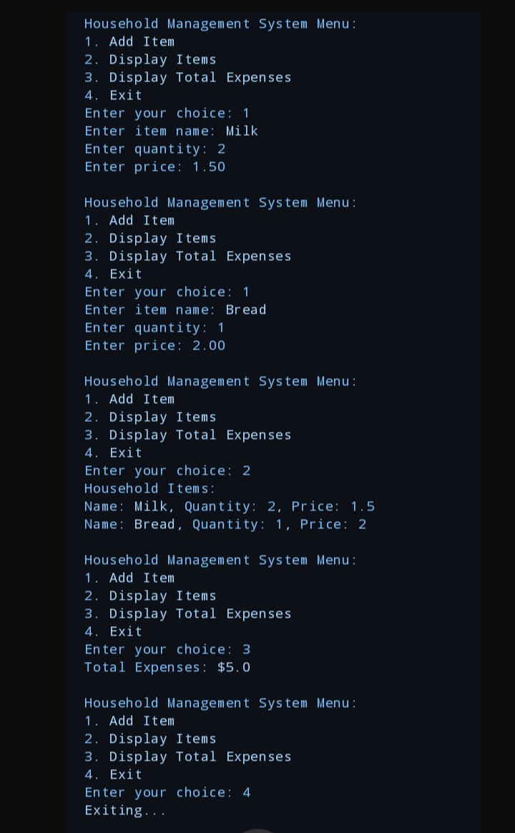

CONCLUSION

A Household Management System (HMS) is essential for efficient home organization and resource management. By integrating various aspects such as budgeting, scheduling, inventory tracking, and task delegation, an HMS can streamline daily operations, enhance communication among household members, and improve overall productivity.

In conclusion, implementing an effective HMS not only simplifies routine tasks but also fosters a harmonious living environment. By leveraging technology and organization strategies, families can better manage their time, finances, and responsibilities, ultimately leading to a more balanced and enjoyable home life.